Name:  Class: | ____________________________________  ________________ |  | Date:_________
 | Year 11 Essentials  Test 2, 2019  Topic – Fractions, Decimals, Percentages |  | / 35  %
Total Time: | 40 min TOTAL
Weighting: | 5 %
Equipment: | 1 page of notes, calculator

NON-CALCULATOR SECTION - 25min

Question 1 2 marks

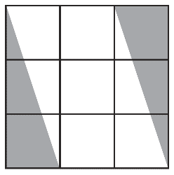
What fraction of the shape is shaded, in simplest form?

Question 2 5 marks

Write the fractions marked by a dot on the number line:

Question 3 2 marks

Write the following fractions in ascending order:

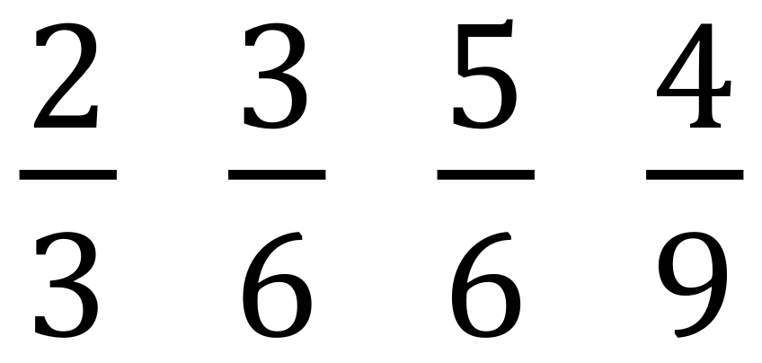

Question 4 10 marks

Evaluate the following. Make sure to leave all answers as proper or mixed fractions.
If possible, simplify your answer.

 | Year 11 Essentials Name: ____________  Test 2, 2019  Topic – Fractions, Decimals, Percentages
CALCULATOR SECTION – 15 min

Question 5 4 marks

Complete the table:

Fraction | Decimal | Percentage
 |  | 25 %
 | 0.35
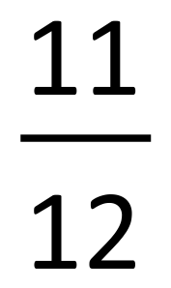
 | 2.19

Question 6 3 marks

Jakob has 50 apples at the start of the day. At the end of the day he has sold 43 apples.

- What percentage of apples has Jakob sold?

- What fraction of apples remain unsold?

Question 7 4 marks

- In a school of 250 children, 4% were ill with chicken pox. How many children had chicken pox?

- In a test out of 80 marks, students have to get 45% to pass the test. How many marks do the students need to pass the test?

Question 8 5 marks

- Mrs. Stretch earns $3500 a month. She saves $280 a month. Savings is what percent of her income?

- A chemist analyses 28g of an alloy and finds that it contains 7g of tin, 14g of lead and 7g of other metals.
  - What is the ratio of lead to tin to other metals?

  - What percentage of the alloy contains lead?

  - What fraction of the alloy contains lead and other metals?

End of Test

